
Department of Computer Science & Engineering

A Report on
Integrating Decentralized Lending and Borrowing with Decentralized Exchanges
Blockchain & Distributed app Development - CSE635

Submitted in partial fulfillment of the requirements for the award of the degree of

Bachelor of Engineering in Computer Science & Engineering

By

Sharanya M S 1MS22CS130
Yash Suresh Gavas 1MS22CS163

Under the guidance of

Uzma Sulthana
Assistant Professor

M S RAMAIAH INSTITUTE OF TECHNOLOGY
(Autonomous Institute, Affiliated to VTU)
BANGALORE-560054
www.msrit.edu
May-2025

Department of Computer Science and Engineering

M S Ramaiah Institute of Technology
(Autonomous Institute, Affiliated to VTU)

Bangalore – 560054



CERTIFICATE

This is to certify that Sharanya M S (1MS22CS130) and Yash Suresh Gavas (1MS22CS163) have completed the “Integrating Decentralized Lending and Borrowing with Decentralized Exchanges” as part of Blockchain & Distributed app Development - CSE635 course. I declare that the entire content embodied in this B.E CSE, 6th semester report contents are not copied.

Guided by
Uzma Sulthana Assistant Professor,
Dept. of CSE, RIT

Department of Computer Science and Engineering

M S Ramaiah Institute of Technology
(Autonomous Institute, Affiliated to VTU)

Bangalore – 560054

Evaluation Sheet

USN | Name | Literature survey and Explanation Skills  (5) | Coding & Documentation (5) | Total Marks  (10)
1MS22CS130 | Sharanya M S
1MS22CS163 | Yash Gavas

Evaluated By

Name: Uzma Sulthana
Designation: Assistant Professor
Department: Computer Science & Engineering, RIT
Signature:

Table of Contents

Sl No | Content | Page No
 | Abstract | 5
 | Introduction | 6
 | Literature study | 7
 | Coding | 10
 | Results snapshots and discussion | 14
 | Future Scope | 21
 | Conclusion | 22
 | References | 23

ABSTRACT

The design and development of a comprehensive Decentralized Finance (DeFi) platform that integrates lending, borrowing, token swapping, and portfolio management functionalities. Built with a modern technology stack including React, Node.js, and PostgreSQL, the platform offers robust features such as real-time price feeds, an automated liquidation engine, and an intuitive admin dashboard for monitoring activity. User authentication, privacy controls, and seamless social sharing further enhance the user experience. The solution aims to provide a secure, scalable, and user-friendly environment for managing digital assets, contributing to the broader adoption of decentralized financial services.

INTRODUCTION

Decentralized Finance (DeFi) has emerged as a transformative force in the financial sector, enabling open, permissionless, and borderless access to financial services through blockchain technology. Traditional financial systems are often constrained by centralized control, limited accessibility, and high operational costs. In contrast, DeFi platforms leverage smart contracts and distributed ledgers to facilitate transparent, automated, and trust less transactions, reducing reliance on intermediaries and enhancing user autonomy.
The DeFi platform detailed in this report is designed to address the growing demand for integrated financial services within the crypto ecosystem. It provides a unified interface for lending and borrowing digital assets, allowing users to earn yield or access liquidity by collateralizing their holdings. The token swapping feature ensures optimal exchange rates across multiple cryptocurrencies, while the portfolio management module enables users to monitor their positions and track performance in real time. An admin dashboard offers comprehensive oversight of platform activity and user transactions, supporting operational transparency and security.
Security and risk management are central to the platform’s architecture. The automated liquidation engine protects against undercollateralized positions, safeguarding both users and the protocol. Real-time price feeds sourced from leading exchanges ensure accurate asset valuations, and robust authentication mechanisms maintain the integrity of user accounts. The inclusion of social sharing features with privacy controls encourages community engagement while respecting user confidentiality.
The platform is built using a modular project structure, with a React frontend, Express backend, and smart contracts deployed on the blockchain. State management is handled by TanStack Query, and styling is achieved with Tailwind CSS and shadcn/ui components. The backend supports both in-memory and persistent PostgreSQL storage, offering flexibility for development and production environments. The system is designed for ease of deployment, scalability, and extensibility, positioning it as a viable solution for advancing the adoption of decentralized finance.

LITRATURE STUDY

Adwani & Rao (2025) — Decentralized Finance (DeFi): Reshaping Traditional Banking Systems
Adwani & Rao (2025) examine how DeFi, powered by blockchain and smart contracts, is transforming traditional banking by enabling peer-to-peer financial services such as lending, borrowing, and trading without intermediaries. Their review highlights DeFi’s strengths: increased transparency, reduced transaction costs, faster processing, and greater financial inclusion-especially for underbanked populations. The paper also notes that DeFi platforms operate 24/7, are accessible globally, and empower users by giving them full control over their assets. However, the authors identify several weaknesses and challenges: regulatory uncertainty, security vulnerabilities (such as smart contract bugs and hacks), scalability issues, and a lack of consumer protection. The study also points out that most DeFi research is based on secondary data, and the field’s rapid evolution means findings can quickly become outdated, while the complexity of DeFi may limit its accessibility for non-experts.[1]

Kaplan, Benli & Alp (2023) — Decentralized Finance and New Lending Protocols
Kaplan, Benli & Alp (2023) focus on DeFi lending protocols, explaining how blockchain and smart contracts allow users to lend and borrow cryptocurrencies directly, without the need for banks or credit checks. The main strengths identified are efficiency, transparency, and inclusivity: anyone with internet access can participate, and processes are automated and cost-effective. DeFi lending can increase access to credit for those excluded from traditional finance and offers new ways for investors to earn yields on their assets. Nevertheless, the paper also highlights weaknesses such as regulatory uncertainty, potential security risks, and the fact that DeFi lending often relies on over-collateralization, which can limit capital efficiency and broader adoption. The authors also note that DeFi is still largely replicating traditional financial services, and its future growth will depend on legal standards and cultural acceptance.[2]

Decentralized Finance (DeFi): Opportunities, Challenges, and Policy Implications (Eurofi, 2022)
This paper outlines how DeFi leverages permissionless blockchains and smart contracts to automate financial services, enabling transactions without intermediaries and providing high transparency, security, and efficiency when protocols are properly coded. The strengths of DeFi highlighted include the automation of agreements, irreversible and easily trackable transactions, and the potential for significant cost reduction and inclusivity compared to centralized finance. However, the paper also notes weaknesses such as the risk of coding errors in smart contracts, regulatory uncertainty, and the possibility of increased illicit activity due to the lack of intermediaries overseeing transactions. The irreversible nature of blockchain transactions, while enhancing transparency, can also make error correction and dispute resolution challenging.[3]

Blockchain and Decentralized Finance (DeFi): Disrupting Traditional Financial Systems (WJARR, 2024)
This research discusses how DeFi, powered by blockchain technology, disrupts traditional banking by eliminating intermediaries, reducing transaction costs, and fostering more inclusive and transparent financial services5. The strengths identified include peer-to-peer transactions, automated smart contracts, and greater user control over assets, which collectively enhance efficiency and financial inclusion. The paper also points out that DeFi’s transparency and cryptographic security reduce fraud and errors. On the other hand, it acknowledges challenges such as regulatory uncertainty, technological risks, and the need for robust security measures to protect users. The rapid evolution of DeFi means that risks and compliance issues must be carefully managed to ensure sustainable growth and user protection.[4]

Campbell R. Harvey & Daniel Rabetti (2024) — International Business and Decentralized Finance
Harvey and Rabetti (2024) analyze how decentralized finance (DeFi) is reshaping international business by leveraging blockchain and smart contracts to provide accessible, efficient, and borderless financial services. The paper highlights DeFi’s key strengths: it eliminates traditional intermediaries, reduces transaction costs, increases transparency, and fosters financial inclusion, especially for underserved regions. DeFi platforms enable peer-to-peer transactions, operate 24/7, and support programmable, interoperable financial products, offering new opportunities for global businesses to compete, innovate, and manage cross-border activities more efficiently. The authors also discuss how DeFi’s transparency, public accessibility, and composability set it apart from legacy financial systems, potentially democratizing access to capital and financial tools worldwide1.
However, the study also underscores several weaknesses and challenges. DeFi faces significant regulatory uncertainty, as global legal frameworks are still evolving and enforcement is difficult due to the decentralized nature of protocols. Other concerns include security vulnerabilities (such as smart contract bugs and oracle risks), scalability limitations, and the complexity of DeFi products, which may hinder mainstream adoption. The authors note that while DeFi offers transformative potential, its rapid evolution, lack of consumer protections, and the need for robust compliance and security measures present ongoing risks for businesses, investors, and regulators[5]

CODING

Lending.sol

pragma solidity ^0.8.19;

import "@openzeppelin/contracts/token/ERC20/IERC20.sol";
import "@openzeppelin/contracts/security/ReentrancyGuard.sol";
import "@openzeppelin/contracts/access/Ownable.sol";

contract LendingPool is ReentrancyGuard, Ownable {
struct UserDeposit {
uint256 amount;
uint256 timestamp;
}

mapping(address => mapping(address => UserDeposit)) public deposits; // user => token => deposit
mapping(address => mapping(address => uint256)) public borrowings; // user => token => amount
mapping(address => bool) public supportedTokens;
mapping(address => uint256) public totalDeposits;
mapping(address => uint256) public interestRates;

uint256 public constant COLLATERAL_RATIO = 150; // 150% collateral required

event Deposit(address user, address token, uint256 amount);
event Withdraw(address user, address token, uint256 amount);
event Borrow(address user, address token, uint256 amount, address collateralToken, uint256 collateralAmount);
event Repay(address user, address token, uint256 amount);

constructor() {
_transferOwnership(msg.sender);
}

function addSupportedToken(address token, uint256 interestRate) external onlyOwner {
supportedTokens[token] = true;
interestRates[token] = interestRate;
}

function deposit(address token, uint256 amount) external nonReentrant {
require(supportedTokens[token], "Token not supported");
require(amount > 0, "Amount must be greater than 0");

IERC20(token).transferFrom(msg.sender, address(this), amount);

deposits[msg.sender][token].amount += amount;
deposits[msg.sender][token].timestamp = block.timestamp;
totalDeposits[token] += amount;

emit Deposit(msg.sender, token, amount);
}

function withdraw(address token, uint256 amount) external nonReentrant {
require(amount > 0, "Amount must be greater than 0");
require(deposits[msg.sender][token].amount >= amount, "Insufficient balance");

deposits[msg.sender][token].amount -= amount;
totalDeposits[token] -= amount;

IERC20(token).transfer(msg.sender, amount);

emit Withdraw(msg.sender, token, amount);
}

function borrow(address token, uint256 amount, address collateralToken) external nonReentrant {
require(supportedTokens[token], "Token not supported");
require(supportedTokens[collateralToken], "Collateral token not supported");
require(amount > 0, "Amount must be greater than 0");

uint256 collateralAmount = (amount * COLLATERAL_RATIO * getPrice(token)) / (100 * getPrice(collateralToken));

IERC20(collateralToken).transferFrom(msg.sender, address(this), collateralAmount);
IERC20(token).transfer(msg.sender, amount);

borrowings[msg.sender][token] += amount;

emit Borrow(msg.sender, token, amount, collateralToken, collateralAmount);
}

function repay(address token, uint256 amount) external nonReentrant {
require(amount > 0, "Amount must be greater than 0");
require(borrowings[msg.sender][token] >= amount, "Invalid repay amount");

IERC20(token).transferFrom(msg.sender, address(this), amount);
borrowings[msg.sender][token] -= amount;

emit Repay(msg.sender, token, amount);
}

function getPrice(address token) internal pure returns (uint256) {
// In production, this would fetch price from an oracle
return 1000; // Placeholder price
}

function getUserDeposit(address user, address token) external view returns (uint256) {
return deposits[user][token].amount;
}

function getUserBorrowing(address user, address token) external view returns (uint256) {
return borrowings[user][token];
}
}

index.tx

import 'dotenv/config'; // load .env before using process.env

import express, { type Request, Response, NextFunction } from "express";
import { registerRoutes } from "./routes";
import { setupVite, serveStatic, log } from "./vite";
import { liquidationEngine } from "./liquidation-engine";

const app = express();
app.use(express.json());
app.use(express.urlencoded({ extended: false }));

app.use((req, res, next) => {
const start = Date.now();
const path = req.path;
let capturedJsonResponse: Record<string, any> | undefined = undefined;

const originalResJson = res.json;
res.json = function (bodyJson, ...args) {
capturedJsonResponse = bodyJson;
return originalResJson.apply(res, [bodyJson, ...args]);
};

res.on("finish", () => {
const duration = Date.now() - start;
if (path.startsWith("/api")) {
let logLine = `${req.method} ${path} ${res.statusCode} in ${duration}ms`;
if (capturedJsonResponse) {
logLine += ` :: ${JSON.stringify(capturedJsonResponse)}`;
}

if (logLine.length > 80) {
logLine = logLine.slice(0, 79) + "…";
}

log(logLine);
}
});

next();
});

(async () => {
const server = await registerRoutes(app);

app.use((err: any, _req: Request, res: Response, _next: NextFunction) => {
const status = err.status || err.statusCode || 500;
const message = err.message || "Internal Server Error";

res.status(status).json({ message });
throw err;
});

// ALWAYS serve the app on port 5000
// this serves both the API and the client.
// It is the only port that is not firewalled.
const port = 5000;
server.listen({
port,
host: "0.0.0.0",
reusePort: true,
}, () => {
log(`serving on port ${port}`);

// Start the liquidation engine automatically
setTimeout(() => {
liquidationEngine.start();
log("🚀 Liquidation Engine started - monitoring positions for safety");
}, 2000); // Start after 2 seconds to ensure everything is ready
});
})();

liquidation-dashboard.tsx
// State and configuration for the liquidation engine
const [configForm, setConfigForm] = useState({
liquidationThreshold: 1.5,
liquidationPenalty: 0.1,
healthFactorThreshold: 1.0
});

// Fetch real-time liquidation stats and recent events
const { data: stats, refetch: refetchStats } = useQuery<LiquidationStats>({
queryKey: ["/api/liquidation/stats"],
queryFn: getQueryFn({ on401: "returnNull" }),
refetchInterval: 3000, // Real-time updates
});
const { data: events, refetch: refetchEvents } = useQuery<LiquidationEvent[]>({
queryKey: ["/api/liquidation/events"],
queryFn: getQueryFn({ on401: "returnNull" }),
refetchInterval: 3000,
});

// Start/stop engine, update config, manual liquidation
const startMutation = useMutation({ ... });
const stopMutation = useMutation({ ... });
const updateConfigMutation = useMutation({ ... });
const triggerManualLiquidation = useMutation({ ... });

// Engine controls (Start/Stop)
{stats?.isRunning ? (
<Button onClick={() => stopMutation.mutate()}>Stop Engine</Button>
) : (
<Button onClick={() => startMutation.mutate()}>Start Engine</Button>
)}

// Engine configuration form
<form onSubmit={handleConfigSubmit}>
{/* Liquidation Threshold, Penalty, Health Factor */}
<Input ... />
<Button type="submit">Update Configuration</Button>
</form>

// Manual liquidation test
<form onSubmit={handleManualLiquidation}>
<Input ... />
<Button type="submit">Trigger Liquidation Check</Button>
</form>

// Real-time stats and recent events display
<div>{stats?.totalLiquidations}</div>
<div>{calculateSuccessRate()}%</div>
<div>{stats?.totalLiquidatedValue}</div>
<div>{stats?.totalCollateralSeized}</div>
{events.map((event) => (
<div key={event.id}>{event.status} ...</div>
))}
RESULTS SNAPSHOTS AND DISCUSSION
Sign in /Register Page
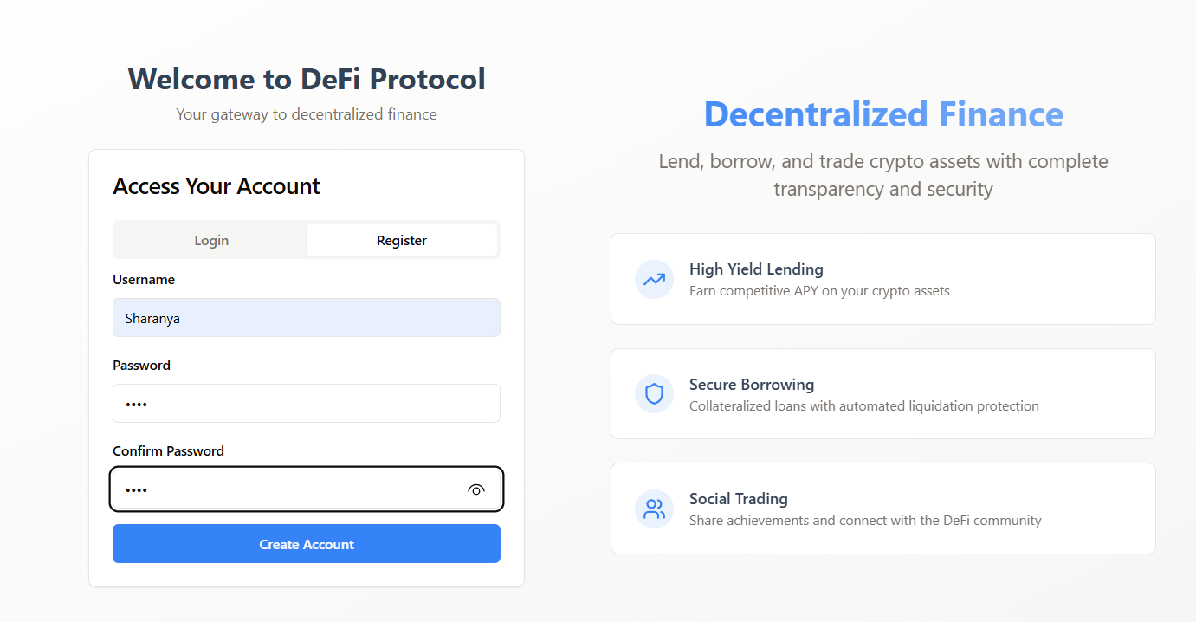
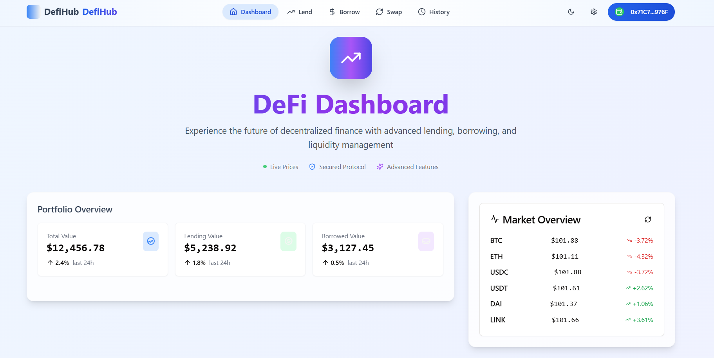
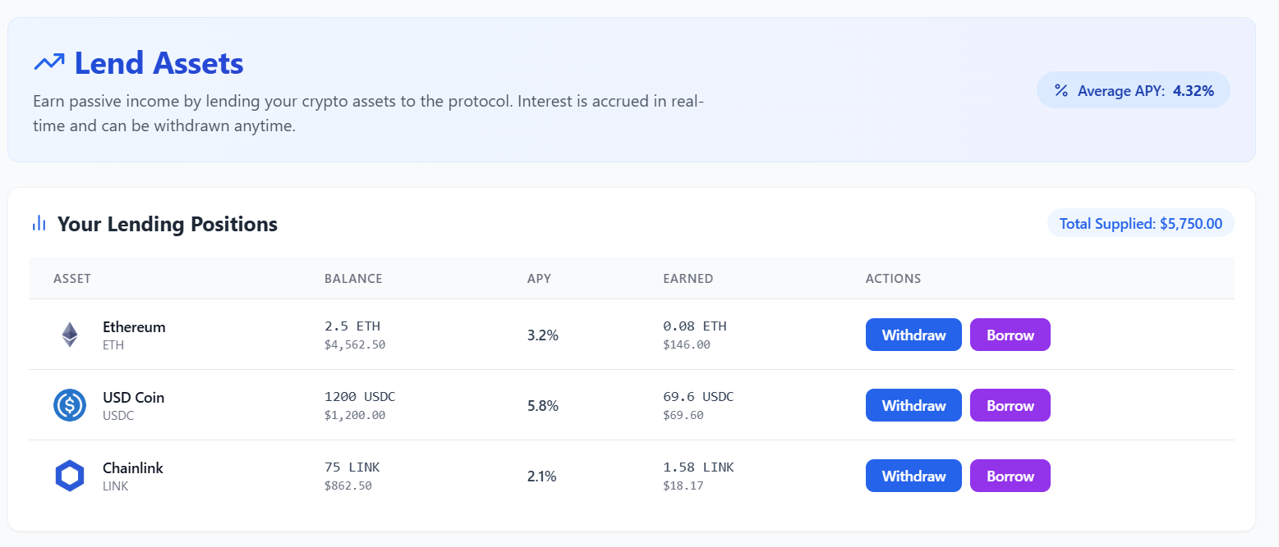
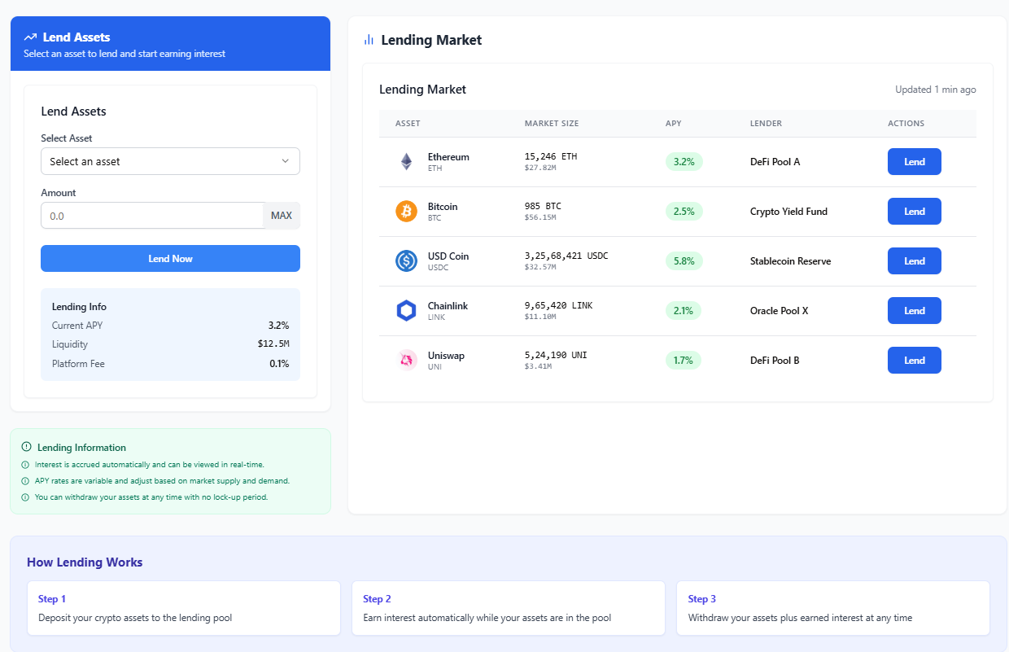

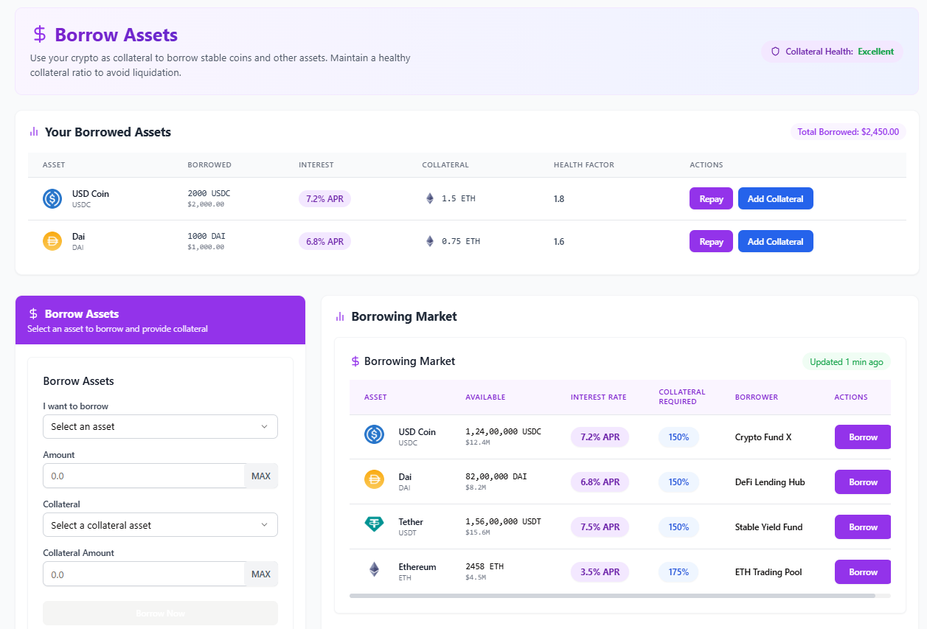
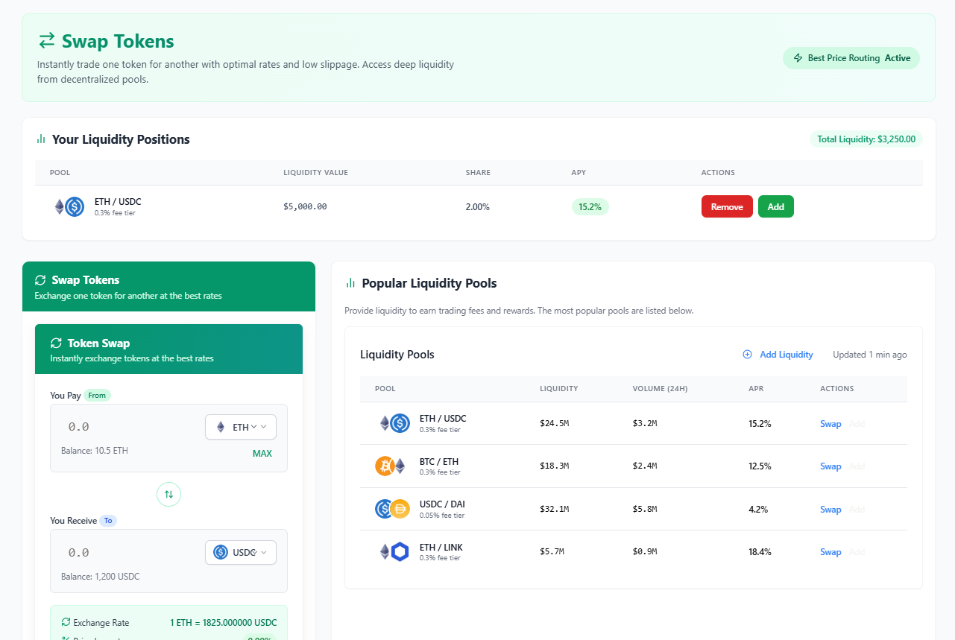

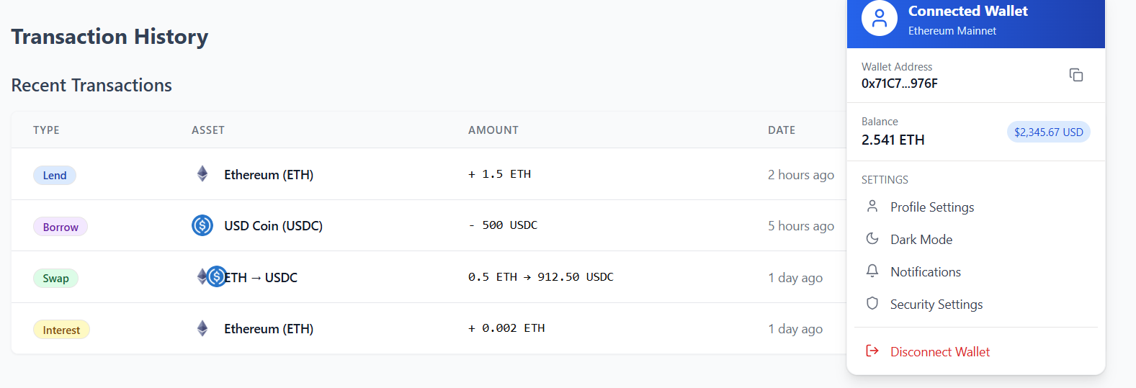
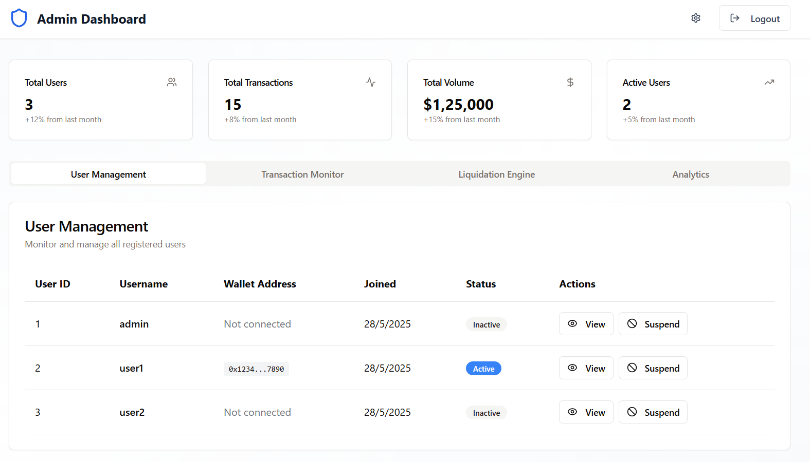
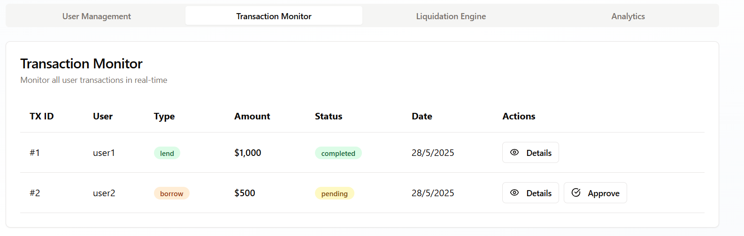
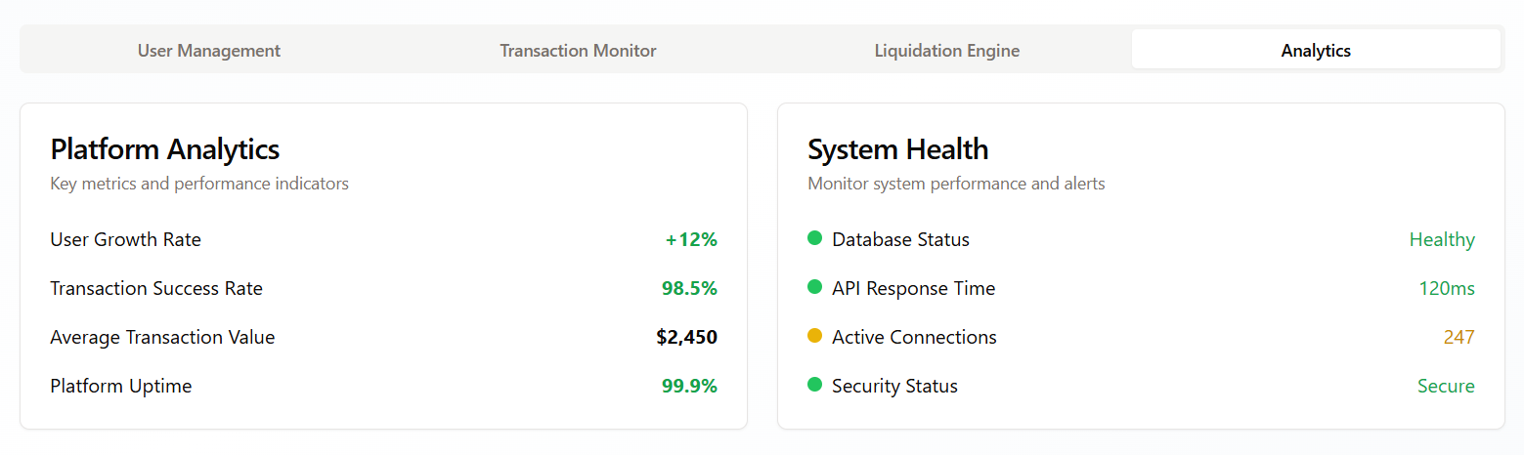
System Implementation and Technology Stack Technology Stack:

System Implementation
The DeFi platform is structured as a full-stack application that integrates decentralized finance functionalities such as lending, borrowing, token swapping, and portfolio management. The system is organized into separate components for frontend, backend, smart contracts, and shared resources, enabling modular development and scalability. The frontend is built with React and communicates with the backend server via RESTful APIs. The backend, developed using Node.js and Express, handles business logic, user authentication, and database interactions. Smart contracts, stored in the contracts/ directory, facilitate core DeFi operations like lending, borrowing, and token swaps on the blockchain. The platform features real-time price feeds, an automated liquidation engine for risk management, an admin dashboard for monitoring activities, and social sharing capabilities. User registration and authentication are managed securely, with an admin account provided for platform oversight. The application supports both in-memory and persistent PostgreSQL database storage, allowing for flexible deployment in development and production environments.

Technology Stack
- Frontend: React, TypeScript, Tailwind CSS, shadcn/ui components
- Backend: Node.js, Express, TypeScript
- Database: PostgreSQL (with in-memory fallback for development)
- Authentication: Passport.js
- State Management: TanStack Query
- Smart Contracts: Located in the contracts/ directory (blockchain platform not specified)
- Styling: Tailwind CSS with shadcn/ui
- Real-time Data: Integrates with external APIs (Coinbase, Pyth, Binance) for live cryptocurrency prices
- Development Tools: VS Code recommended, environment configuration via .env file
- Scripts: Includes commands for development (npm run dev), production build (npm run build), and preview (npm run preview)

Installation and Setup Instructions:

1. Clone the Project Repository

git clone <your-repo-url>
cd Blockchainproject

2. Install Dependencies

npm install

3. Start the Application

npm run dev

- The frontend will be available at: http://localhost:5000

4. Connecting MetaMask to Your Local Blockchain

Step 1: Install MetaMask
- Download and install the MetaMask browser extension from the official website.
- Create a new wallet or import an existing one.

Step 2: Add Your Local Blockchain Network to MetaMask
- Open MetaMask and click on your network dropdown (usually says "Ethereum Mainnet").
- Select Add Network or Add Network Manually.
- Fill in the network details (for a local blockchain, e.g., Hardhat or Ganache):
  - Network Name: Local Blockchain (or any name)
  - New RPC URL: http://127.0.0.1:8545
  - Chain ID: 1337 (or your local chain ID)
  - Currency Symbol: ETH
  - Block Explorer URL: (leave blank for local)
- Click Save.

Step 3: Connect MetaMask to Your DApp
- Open your DApp in the browser.
- Click "Connect Wallet" or similar button in the UI.
- MetaMask will prompt you to connect; approve the connection.

Step 4: (Optional) Import Local Accounts
- If you want to use a specific account (e.g., from Hardhat or Ganache), copy its private key.
- In MetaMask, go to Account > Import Account, paste the private key, and confirm.

Step 5: Verify Connection
- Once connected, your wallet address should appear in the DApp.
- You can now interact with the blockchain using your MetaMask wallet.

Admin Page: Installation, Setup, and Access Instructions

5. Access the Admin Dashboard
- Open your browser and go to: http://localhost:5000/admin
- Default Admin Credentials:
  - Username: admin
  - Password: admin@123
- Log in with these credentials to access the admin dashboard.

6. Admin Dashboard Features
- Monitor platform activity: View user registrations, transactions, and platform statistics in real time.
- Manage users: Approve, suspend, or review user accounts.
- Oversee lending/borrowing: Track active loans, liquidations, and collateral health.
- Token swaps: Monitor swap volume and liquidity.
- Portfolio analytics: Review aggregated user portfolio data and platform performance.
- Security & compliance: Respond to suspicious activity and manage system alerts.

6. Security Recommendations
- Change the default admin password after the first login for security.
- Enable two-factor authentication if available.
- Regularly monitor logs for any unusual activity.
- Restrict admin page access to trusted IPs or use VPN for added security.

7. Troubleshooting
- If you can't access the admin page, ensure the server is running and you've navigated to the correct URL.
- For login issues, reset credentials in the database or configuration file.
- If port 5000 is busy, the app will select another available port—check your terminal output for the correct address.

FUTURE SCOPE

The DeFi platform outlined in this report has significant potential for future enhancements and expansion. Integrating cross-chain interoperability would allow users to manage assets across multiple blockchains, broadening the platform’s reach and utility. The addition of advanced financial instruments such as derivatives, options, and automated investment strategies could attract a wider user base and increase platform engagement. Further, implementing decentralized governance through DAO mechanisms would empower the community to participate in decision-making and protocol upgrades. Enhanced security features, including multi-factor authentication and on-chain analytics for fraud detection, can strengthen user trust. Finally, mobile application development and integration with decentralized identity solutions would improve accessibility and compliance, positioning the platform for mainstream adoption.

CONCLUSION

In summary, the developed DeFi platform successfully integrates essential decentralized financial services such as lending, borrowing, token swapping, and portfolio management within a secure and user-friendly environment. By leveraging modern web technologies and blockchain infrastructure, the platform addresses key challenges in accessibility, transparency, and risk management. With its modular architecture and support for future enhancements, the solution is well-positioned to adapt to the evolving needs of the DeFi ecosystem. Continued development and community engagement will be crucial in realizing the platform’s full potential and driving the adoption of decentralized finance on a global scale.

REFERENCES

- Adwani, R., & Rao, V. S. (2025). Decentralized finance (defi): Reshaping traditional banking systems. European Economic Letters, 0 [10.52783/eel. v15i1. 2432].

- Kaplan, B., Benli, V. F., & Alp, E. A. (2023). Decentralized finance and new lending protocols. PressAcademia Procedia, 16(1), 192-195.

- Truchet, M. (2022). Decentralized Finance (DeFi): opportunities, challenges and policy implications. Eurofi Regulatory Update, 71-75.

- Bakare, F. A., Omojola, J., & Iwuh, A. C. (2024). Blockchain and decentralized finance (DEFI): Disrupting traditional banking and financial systems. World J. Adv. Res. Rev, 23(3), 3075-3089.

- Harvey, C. R., & Rabetti, D. (2024). International business and decentralized finance. Journal of international business studies, 55(7), 840-863.

